#### HUMAN BIOLOGICAL SCIENCES STAGE 2

## **MID-SEMESTER TEST 1**

Part I: Multiple Choice 15 marks

Part III: Short Answer 35 marks

Part II: Extended Answer 10 marks

Total 60 marks

Name: _____________________________

**PART I: MULTIPLE CHOICE [15 marks]**

SELECT THE SINGLE CORRECT ALTERNATIVE IN EACH OF THE FOLLOWING QUESTIONS

___________________________________________________________________

1. A person suffering from a deficiency of red blood cells is unable to carry out prolonged vigorous exercise. The main reason for this is that
2. Any waste products would not be removed rapidly enough.
3. The amount of glucose being transported to the body cells would not be sufficient for the energy required.
4. The concentration of carbon dioxide in the extracellular fluid would become too high.
5. Insufficient oxygen would be carried by the blood.
6. The heart pictured below has been sliced through the plane AB. A view looking through this plane is shown on the right. Blood filled regions are indicated by X and Y.

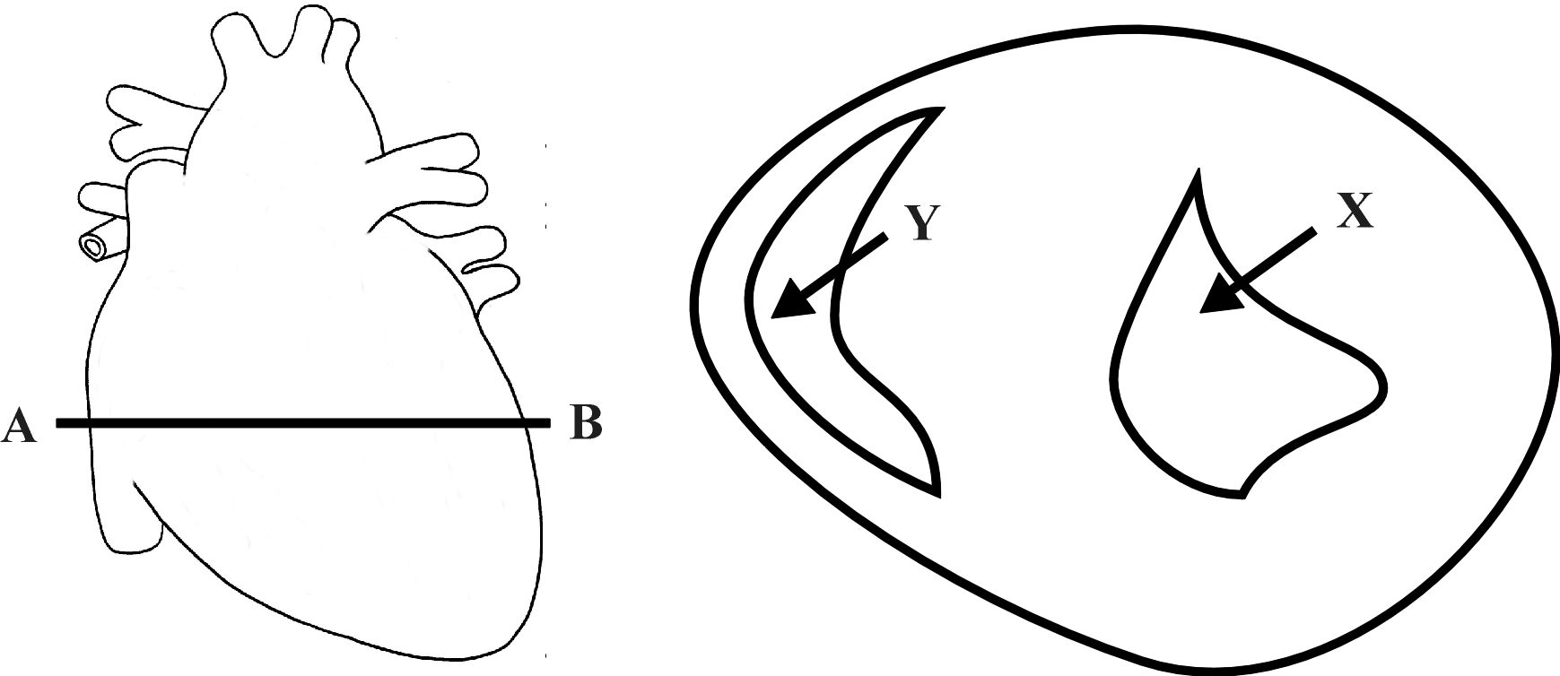

Which of the following four statements about X and Y is not correct?

1. The blood in Y would leave the heart via the pulmonary vein.
2. The blood in X has come directly from the left atrium.
3. The blood in X has a higher concentration of oxyhaemoglobin than the blood in Y.
4. The blood would flow from X into the aorta.
5. Which of the following statements about the transport of respiratory gases is incorrect?
6. Most O2 is transported in combination with haemoglobin.
7. Most CO2 is transported in red blood cells.
8. Some O2 is dissolved in the plasma.
9. Some CO2 is combined with haemoglobin.
10. If a molecule of carbon dioxide was released into the blood at your left foot and then travelled directly to your lungs and out through your nose, it would pass through all of the following structures except one. Which one?
11. Inferior vena cava
12. Pulmonary vein
13. Femoral vein
14. Right ventricle
15. The diagram below represents a cell in fluid. Formulas for the molecules that can move freely across the cell membrane are shown. Some molecules are located inside the cell and other are in the fluid outside the cell.

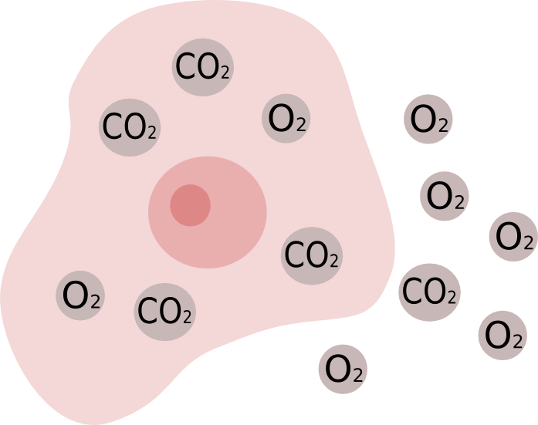

Based on the distribution of these molecules, what would most likely happen after a period of time?

1. The concentration of O2 will increase inside the cell.
2. The concentration of CO2 will remain the same inside the cell.
3. The concentration of O2 will remain the same outside the cell.
4. The concentration of CO2 will decrease outside the cell.
5. Most of the chemical digestion that occurs in the stomach involves the breakdown of:
6. Protein to polypeptides.
7. Fats to fatty acids and glycerol.
8. Polypeptides to amino acids.
9. Carbohydrate to disaccharides
10. In humans, oxygen is carried around the body in chemical combination with a molecule called haemoglobin. This iron based chemical compound has a great capacity to carry oxygen. In humans it increases the blood’s oxygen carrying capacity 65-70 times above that normally dissolved in plasma. The chemical reaction for haemoglobin combining with oxygen is shown below:

Hb + O2 ⇒ HbO2 (in the lungs)

HbO2 ⇒ Hb + O2 (in the body tissues)

Note: Hb = haemoglobin, HbO2 = oxyhaemoglobin

The physical factor that determines how much oxyhaemoglobin is produced is the partial pressure of oxygen. The relationship between these two variables is shown in the graph below.

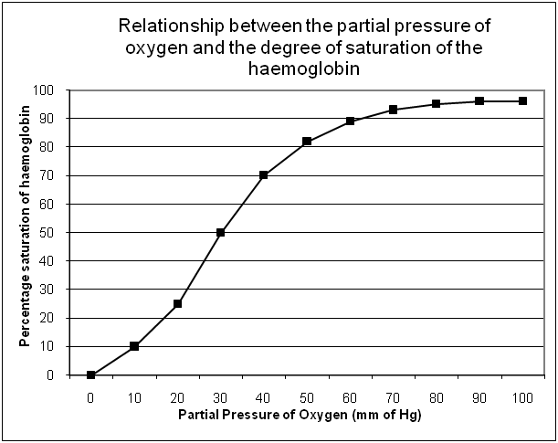

**I**

**II**

**III**

Which point (or points) on the graph best represents the haemoglobin in the lungs?

1. I only
2. II only
3. III only
4. I and II only
5. What is the name of the muscular contractions that move food along the digestive tract?
6. Periosteum.
7. Peristalsis.
8. Pericardium.
9. Perimysium.
10. Below are four lists of molecules. Which list best represents the end products of the process of digestion?
11. Glucose, amino acids, triglycerides
12. Monosaccharides, amino acids, fatty acids
13. Monosaccharides, polypeptides, fatty acids
14. Glycerol, amino acids, lipids
15. The main function of intestinal villi is to
    1. Rhythmically beat back and forth moving food along the intestine
    2. Surround and digest food particles
    3. Greatly increase the area over which absorption of food can occur
    4. Secrete enzymes to complete chemical digestion.
16. The main function of the colon in humans is to
    1. Absorb the products of digestion
    2. Digest cellulose
    3. Provide temporary storage for excretory matter (i.e. faeces)
    4. Absorb water from undigested food
17. Which of the following statements about bile is correct?
18. Bile is produced and stored in the liver
19. The gall bladder stores and concentrates bile
20. The pancreas synthesises bile and transports it to the duodenum via the common bile duct
21. Bile chemically breaks up large lipid molecules into smaller ones
22. The structures most directly involved in providing oxygen to and removing carbon dioxide from the cells are:
23. Veins and arteries.
24. Trachea and lungs.
25. Mouth and nose.
26. Capillaries and alveoli.
27. In a healthy human, blood pressure would be lowest in:
28. The pulmonary artery.
29. A brain capillary.
30. The aorta.
31. The hepatic vein.
32. Diagrams, tables, and graphs are used by scientists mainly to
33. design a research plan for an experiment.
34. organize data.
35. test a hypothesis.
36. predict the independent variable.

PART II BEGINS ON THE NEXT PAGE

**PART II: SHORT ANSWERS [35 marks]**

Write answers to **ALL** questions on the ruled lines after each question or in the spaces provided within each table.

Question 1

Study the diagram below:

One complete cardiac cycle (0.8 seconds)

1. What is ventricular systole? [1]
2. What is atrial diastole? [1]
3. How long does ventricular systole last? (Use the diagram above to calculate.) [1]
4. During which phase would blood pressure be at its lowest? [1]
5. While the ventricles are in a state of diastole, why does the blood pressure remain high in the arteries? [1]

Question 2

The diagram below shows the stomach lining as viewed through a light microscope at a magnification of 100x.

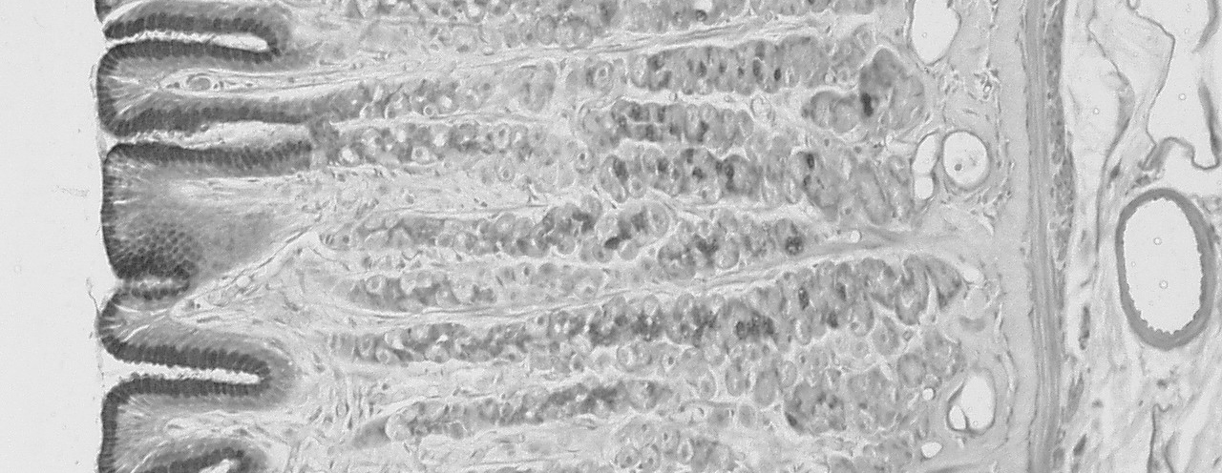

**Parietal cells**

**Chief cells**

**Mucous**

**neck cells**

Glands in the stomach consist of three distinct types of cells (as shown in the diagram). Each cell type secretes a different substance. Name three substances that are secreted by the stomach and describe the function of each.

(6 marks)

Question 3

1. Below is a diagram of the human heart. Write the correct name of the parts in the blank boxes [4]

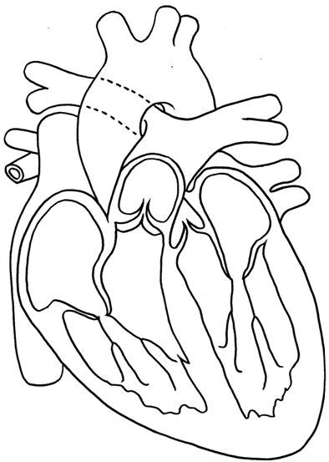

(Valve)

(Chamber)

1. Clearly label on the diagram above the location of the SA node. [1]
2. What is the function of the SA node? [1]

Arteries and arterioles are able to adjust their diameter to alter blood flow to organs. This is normally controlled by nerves, but some substances can alter the diameter of blood vessels.

1. What effect does adrenaline have on the blood vessels of skeletal muscles and the heart? [1]
2. What effect does the build up of wastes (such as lactic acid) have on blood vessels in skeletal muscles? [1]

Question 4

The diagram below shows the organs of the digestive system.

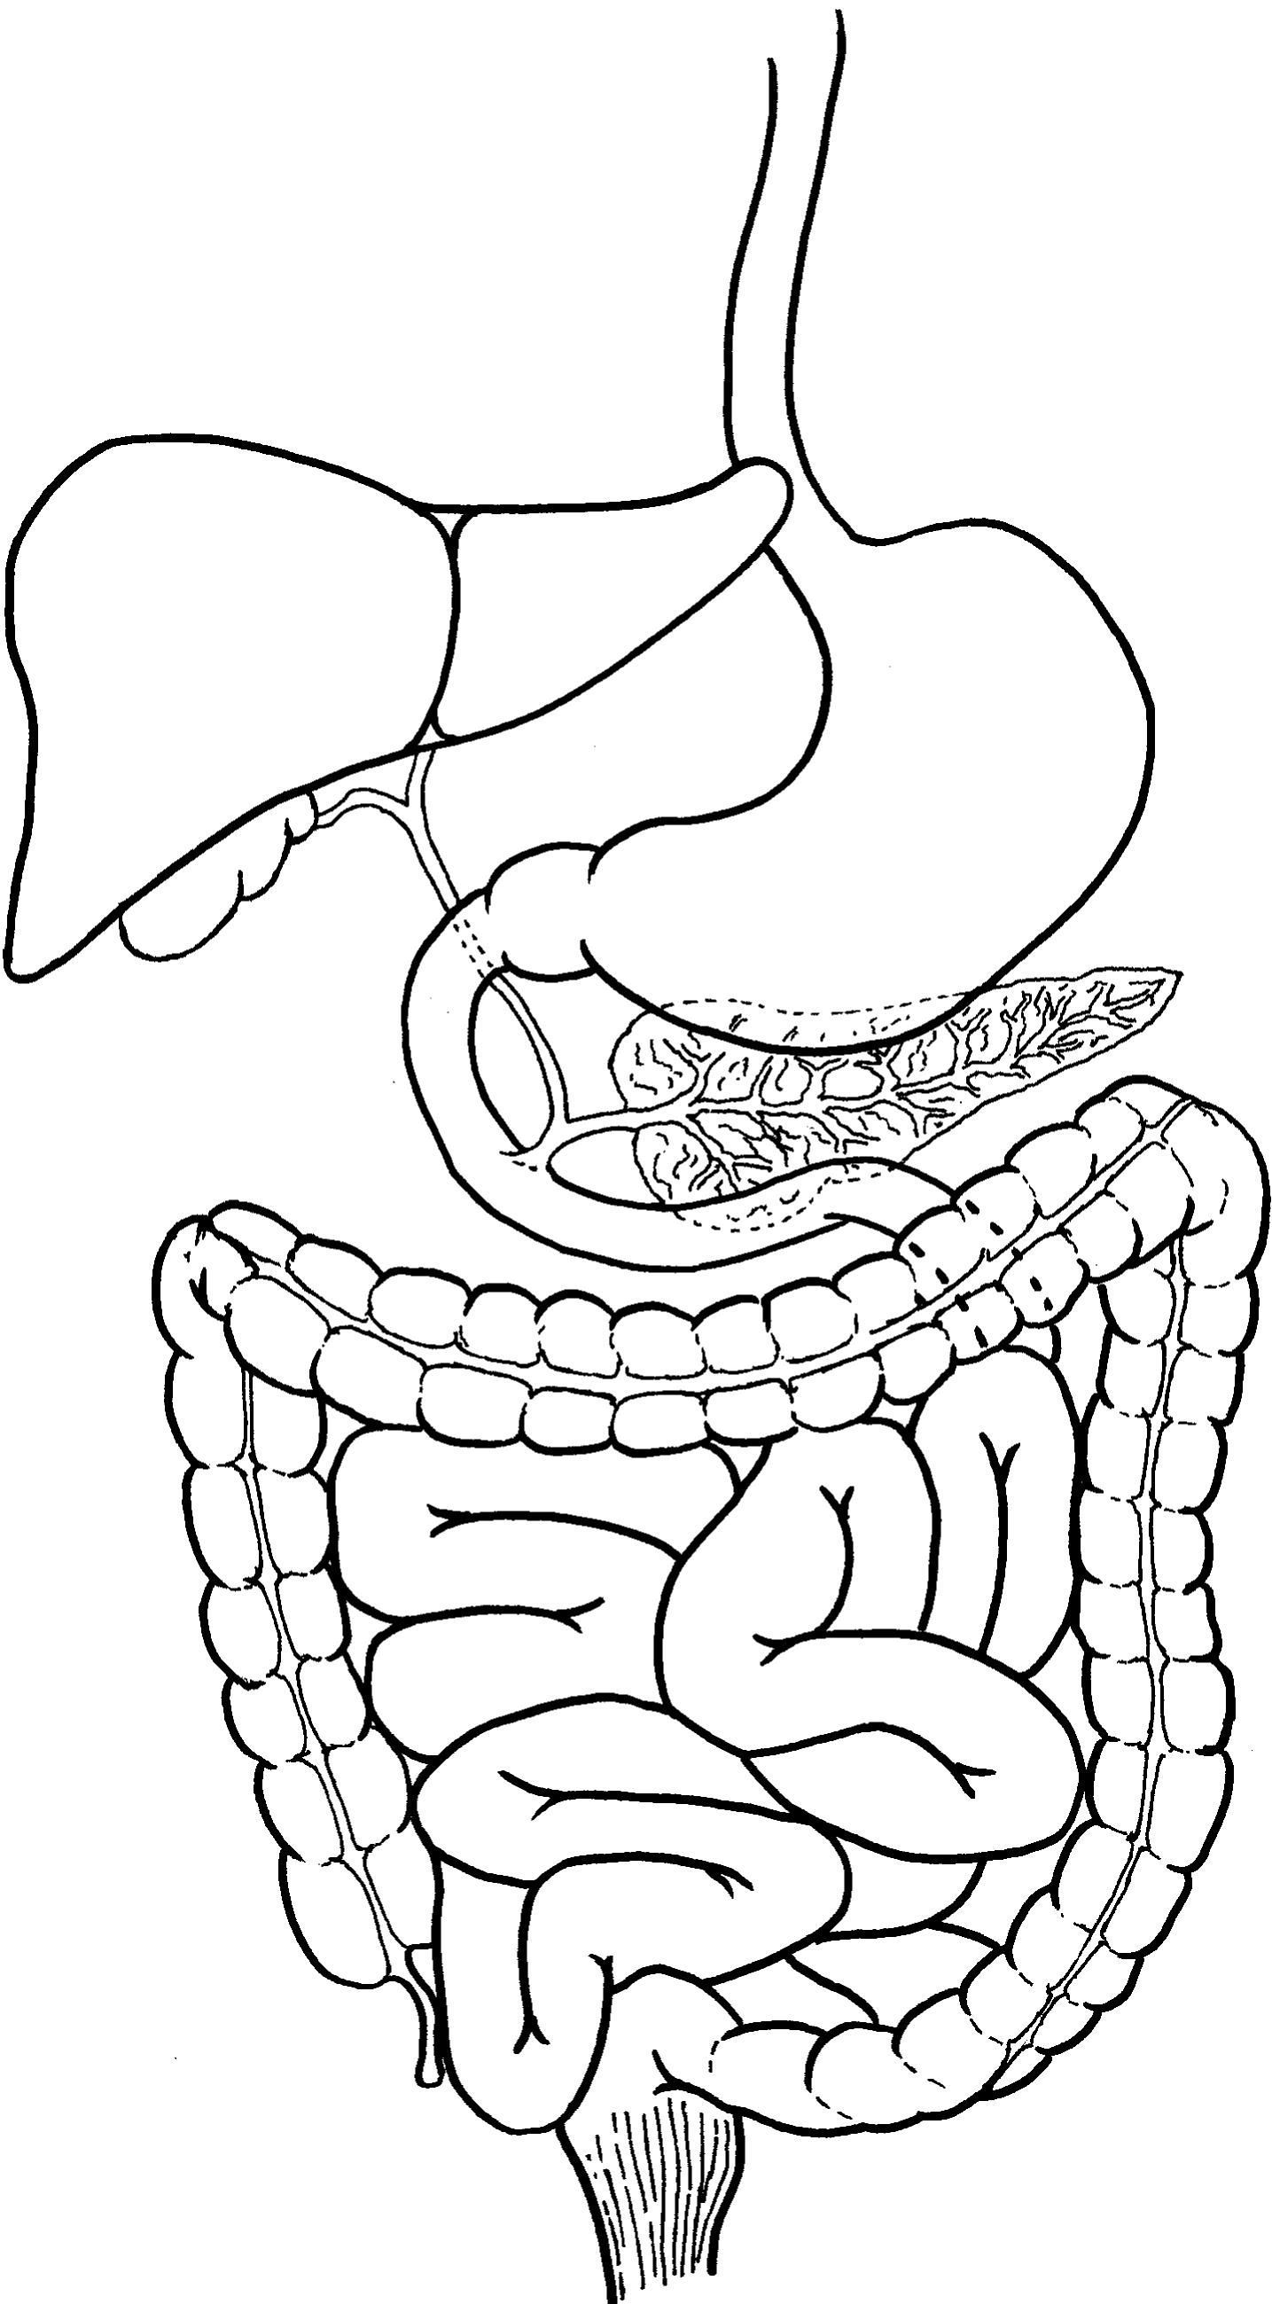

(i)

(ii)

(iii)

(iv)

(v)

(vi)

(a) Identify the following labelled structures:

(ii) ______________________ (v) _________________________

(iii) ______________________ (vi) _________________________

(2 marks)

(b) Name two enzymes secreted by (iii) and describe the function of each.

(4 marks)

Question 4

**Key facts about cardiovascular disease in Australia during 2006-07** (http://www.aihw.gov.au/cvd/index.cfm)

|  |  |  |  |
| --- | --- | --- | --- |
|  | **Prevalence - number of Australians with condition** | [**Hospitalisations**](http://www.aihw.gov.au/cvd/methodological_issues.cfm#Hospitalisations) | [**Deaths**](http://www.aihw.gov.au/cvd/methodological_issues.cfm#Deaths) |
| All cardiovascular diseases | 3,702,500 | 469,817 | 45,670 |
| [Coronary heart disease](http://www.aihw.gov.au/cvd/coronary_disease.cfm) | 637,900 | 162,328 | 22,983 |
| [Stroke](http://www.aihw.gov.au/cvd/stroke.cfm) | 225,770 | 34,476 | 8,484 |
| [Heart failure](http://www.aihw.gov.au/cvd/heart_failure.cfm) | 263,000 | 43,681 | 2,352 |
| [High blood pressure](http://www.aihw.gov.au/cvd/high_blood_pressure.cfm) | 2,100,700 | unknown | unknown |
| [Peripheral vascular disease](http://www.aihw.gov.au/cvd/peripheral_vascular_disease.cfm) | Unknown | 25,813 | 2,163 |
| [Rheumatic fever and  rheumatic heart disease](http://www.aihw.gov.au/cvd/rheumatic_heart_disease.cfm) | 1,402 | 2,561 | 285 |

1. Which type of graph would be best to present the data in the table above? [1]
2. What percentage of Australians who suffered heart failure died from this disease? [1]

Coronary heart disease is caused by atherosclerosis of the coronary blood vessels.

1. What is atherosclerosis? [1]
2. A common early warning sign of coronary heart disease is angina. What is angina? [1]
3. What is the main difference between a heart attack and a stroke? [1]

If a group of medical researchers wanted to test the effectiveness of a new drug in reducing the blood pressure of people with abnormally high blood pressure they would carry out a carefully designed scientific investigation.

1. What would be the independent variable in such an experiment? [1]
2. What would be the dependent variable? [1]
3. The medical researchers would probably use a placebo in their experiment. What is a placebo? [1]

Question 5

The blood transports nutrients and wastes. Below is a diagram that shows the components of the blood of a human.

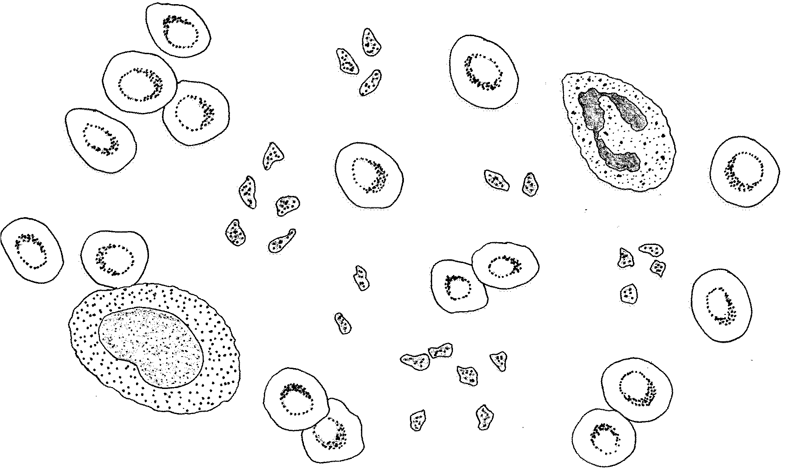

X

Z

Y

W

(c) Describe the composition of the fluid labelled ‘W’. [3]

PART III BEGINS ON THE NEXT PAGE

**PART III: EXTENDED ANSWERS [10 marks]**

Write your answers to these questions on the lined paper on the following pages.

#### Answer both questions.

Question 1

Describe the changes in fluid pH along the alimentary tract and discuss how these changes affect the activity of digestive enzymes.

[6]

Question 2

Discuss four differences between arteries and veins.

[4]

END OF TEST